Friday, December 13, 2019

6th Grade Community News

Dear Students and Parents,

Insha’Allah you have a restful and enjoyable winter break. Thank you for your continued partnership to ensure your children can achieve their highest potential. Please continue to check the PowerSchool Parent Portal a couple of times each week to support your child in completing late assignments.

*Unit packets were sent home for Unit 3. They will be due on January 10 2020.
*Students traveling early will have their unit packet to supplement for missed work for math. If they would like to do extra work they can start on adding and subtracting integers.

Mark Your Calendars!
- Winter Break 12/21-1/5
- Wednesday 1/15: CS3 Induction Ceremony
- Friday 1/17: Trimester 2 Progress Reports sent home
- Monday 1/20: Teacher Work Day, no school for students
- Friday 1/24: CMS Girls Lock on (4:00pm – 9:00pm)

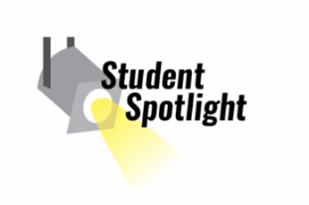
Spotlight on Students
This week, we would like to recognize the following students for demonstrating knowledge and insight. This shows strength in Intellectual Literacy …..

Lyla Gazal Aydin Akhoon Kareem Alawait Mariam Hamdan

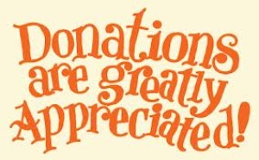
Classroom Donations
At this point in the year, we are gladly accepting the following donations:

- Boxes of adhesive bandages
- Expo © brand dry erase markers
- Staplers
- Board games for indoor recess
- Hand Sanitizer

Students who wish to donate will earn extra credit if they also send Mrs. Diana an email including the following information: What made you want to bring in a classroom donation? How did you pay for the donation? Why is it important to take good care of personal materials and school materials (inanimate objects)? Why is it important to respect and honor the privacy and property of others? Email due Friday December 20th.

2019 - 2020 Theme:
Peace: Gracious, Blessed, Generosity

Unit 3 Intellectual Literacy: Knowledge, Insight, Connectivity

Unit 3: Intellectual Literacy
Each of the seven units that are taught throughout the school year focus on a different literacy designed to transform students in a holistic way. This third unit is all about Intellectual Literacy. Students have learned that having Intellectual Literacy means you work hard to expand useful knowledge and by demonstrating concentration, thought, and reasoning.

Quranic Arabic
What are the manners of reading the Qur’an?
How can we use vocabulary to enrich our language?
- Daily Qur’an recitation Halaqa
- Building meaningful sentences using our knowledge of the past tense verb and the doer
- Learning about the characteristics of letters
- Qur’an memorization

Islamic Studies
Seerah of the Prophet Muhammad ﷺ
- The way in which Allah guided many of the companions
- The persecution that the Prophet Muhammad ﷺ and his companions endured
- The way in which Allah provided for and protected the Prophet ﷺ in Makkah
- The character of the Prophet ﷺ and his companions in spite of the difficulties they faced

Math
What are whole numbers, integers, and rational numbers?
How are they related?
- Adding and subtracting integers
- Comparing and ordering integers and rational numbers
- Solving and graphing inequalities

Science
What are earthquakes and volcanoes?
- How are earthquakes measured?
- How do seismographs work?
- What are the stages for volcanic activity?
- What landforms do lava and ash create?

English Language Arts
Wisdom develops through examining connectivity of communicating our ideas.
- Recognize how people are affected by persuasion
- Identify and analyze persuasive techniques, appeals, language, and images in print and non-print texts
- Argumentative and Debate Writing

Social Studies (World History)
- Economic Systems
Trimester 2 Culminating Project
Market Day
- Students will create original products to sell in school
  - Computation of Profit, Margins, Cost of product
  - Planning process and implementation of product development
  - Research writing to advertise product
  - Poster to showcase advertisement
If you ever have any questions or concerns, please feel free to contact us.
Mrs.Diana (6A) ,Mr. Tauhidi (6B), Ms. Sabri (6C)

