Wedesday, October 23, 2019

6th Grade Community News

Dear Students and Parents,

As-Salamu ‘Alaykum. Insha’Allah this reaches all of you in the best of health and iman!

Mark Your Calendars!
- Thursday 10/31: Cranbrook Field Trip
- Tuesday 11/05 : No school for students
- Sunday 11/10: Children’s Performance (Attendance Mandatory)
- Monday 11/11: No School
- Wednesday 11/27: Half day for students
- Thu & Fri 11/ 28th and 29th: Fall Break No School

Spotlight on Students
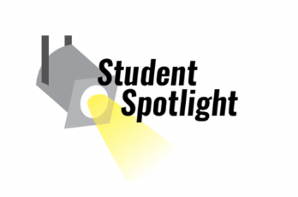
This week, we would like to recognize the following students for radiating positive energy and consistently making good choices. This shows strength in Moral Literacy …..

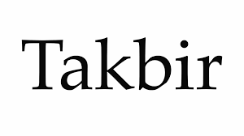
Aleena Mallik, Ali Qoran, Ammar Nusier

Children’s Performance
Every year Crescent Students feel the impact of the children’s performance, especially this time of year! Our schedules change, students take on challenging roles, and they preserver to accomplish both school work and perfecting their roles.
The annual Children’s Performance will start at 1pm. Students should arrive to the Civic Center no later than 12:30pm.

Students volunteered to bring in certain props for our performance. We are still missing the following props. Please DO NOT buy props. Only send them if you already have them at home.
- Big Cardboard boxes (2)
- Thick Rope
- Long belt
- Small metal pitcher
- Small bucket
- Big tall Bucket
- White hair Wig
- Big Glasses (for Grandma)

We appreciate all your help! Please send in any props you have by Thursday October 24th.

2019 - 2020 Theme:
Peace: Gracious, Blessed, Generosity

Unit 2 Moral Literacy: Energy, Synergy, Duality, & Principles

Unit 2: Moral Literacy
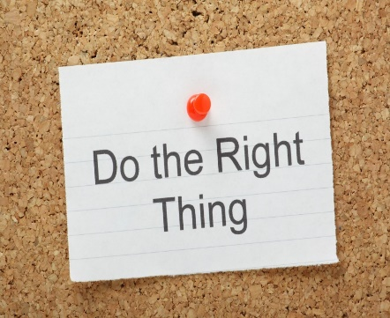
Each of the seven units that are taught throughout the school year focus on a different literacy designed to transform students in a holistic way. This second unit is all about Moral Literacy. Students will learn that having Moral Literacy means to make the right choice when faced with a decision on how to act. Actions can be classified by their intention (good vs. bad), their acceptability in Islam (halal vs. haram), and their effects (positive vs. negative). Students will understand the duality in making decisions and become aware of their own thought processes that lead them to make different choices.

Quranic Arabic
What are the manners of reading the Qur’an?
What was Prophet Musa’s (as) way of being? (the story of Prophet Musa (as) from the Qur’an.)
- Daily Qur’an recitation Halaqa
- Vocabulary, Verbs, and Tajweed Quizlet games
- The verbal sentence: Past tense verbs.
- The exits of letters: where letters exit from and how to pronounce them correctly.
- Qur’an memorization.

Prophetic Guidance
The Seerah of The Prophet (saw)
- Why did Allah (swt) send us a human Prophet?
- Old narratives, new perspectives
- Ways of Being

Math
Fractions (Ch. 4)
- Multiply and divide fractions involving mixed numbers
Introduction to Integers
- Number line activity
Science
Fossils (Ch. 8)

- Plate tectonics activity
- Science Fair project

Language Arts
How can a deep understanding of literature be accomplished?
- Through connections made among ideas and between texts
- Through the acquisition of a vast vocabulary
- Through the use of comprehension strategies when reading
- Through the development of skills needed for using textual evidence

Social Studies
What types of systems and patterns reoccur in geography?
- Themes of geography

Trimester 1 Culminating Performance
What are the rights and responsibilities of each performer?
- Performance practice procedures
  - Recite with expression, maintain eye contact, voice projection, clear speech, confident stance

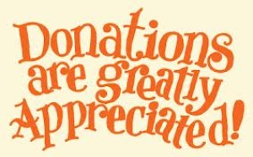
Classroom Donations
At this point in the year, we are gladly accepting the following homeroom donations:
- Hand Sanitizer

If you ever have any questions or concerns, please feel free to contact us.

Jazakumu l lahu Khaiyra for reading this week’s newsletter!
Mrs.Diana (6A) and Mr.Tauhidi (6B) Ms. Sabri (6C)

